Heart Preschool Newsletter
Introduction
We’ve had another busy term of learning and play at Heart Preschool! It’s been a pleasure getting to know our new friends that have joined us since Easter; a big welcome to you all! You have all settled in so well and are already making such good progress.
We’re again very grateful to have had no coronavirus cases and no closures. Thank you again to our families and staff for doing all they can to keep everyone safe as restrictions begin to ease. We hope you have been able to be reunited with some of your loved ones after a long time apart. Well done everyone for getting through lockdown number three! As ever, we will continue to do all we can to keep your little ones safe whilst they are with us.
What’s been happening at Heart?
This term we have been making the most of the sunshine (plus a few very exciting and rain storms!) and having lots of time playing outside. We’ve had sand play, water play, nature collages, climbing, chalk drawings, group chasing games – today was all about what’s the time Mr. Wolf…and lots and lots of ice cream selling role play!
We have also brought back our Tuesday Music & Movement sessions led by the very talented Rachel. These have been great fun, and the children have loved having some quality time to sing and dance to their hearts content!
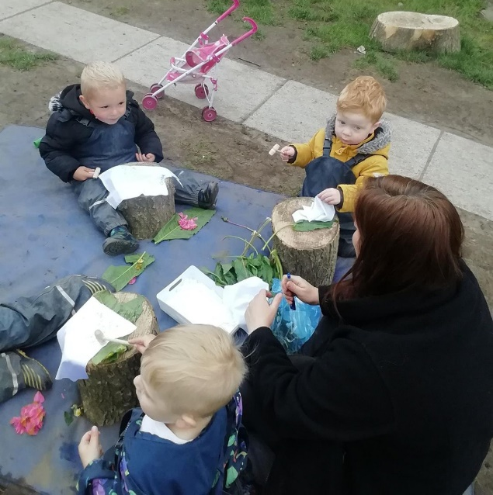
Things to bring to preschool
As we enter into summer please ensure your child has a named bottle of sunscreen with them at preschool, along with a sunhat, and also a pair of wellies and a coat (for those unexpected rain storms!). Please can you also ensure your child’s name is on their clothes and bags. Thank you!
Home Learning/Show & Tell
At Heart Preschool we love to hear about things you and your child are doing at home. If there is an event of significance for your family that you have or will be celebrating, we’d love to hear about it! The children love to share these things with their friends during carpet or home time, so please do send in any photos or objects you are happy to share. Equally, we love to plan activities based on your child’s interest and what is important to them, so do let us know of any significant events or celebration that are upcoming and we can plan activities to support them to share their interests with others.
A quick reminder that you can also post any activities or WOW moments your child has done at home on the ‘Journey’ section of the Famly app. We love hearing about them and celebrating them with you!
Extra hours
We are pleased to announce we will be open for an hour longer each day from 7th June 2021. We hope this will support families especially those with older children in school, working parents and other individual family circumstances.
The 5 hour daily sessions will continue as normal and if your child claims the government funded hours this will stay the same.The extra hour (bubble 1 -2.05-3.05pm and bubble 2 -2.15-3.15) will cost £7.50 and you can book by contacting Angela (Manager) or Rebekah (deputy).
Please book ASAP as places are limited due to adult to child ratios.
Reading Books
A reminder to our Bubble 1 parents to please bring your child’s reading books and reading diaries back each day they attend. We aim to change their book once a week. We also love to read the notes you make in their reading diaries about how they have done with their reading with you at home, so please do fill them in whenever you read with your child at home!
Dates for the diary
- June half term: 31st May – 4th June
- Trip to the park: 8th June
- Parents ‘evenings’: 9th & 10th June 2.45-4pm
- Last day of summer term: Thursday 15th July
- INSET Days (Staff Only): Friday 16th July & Wednesday 1st September
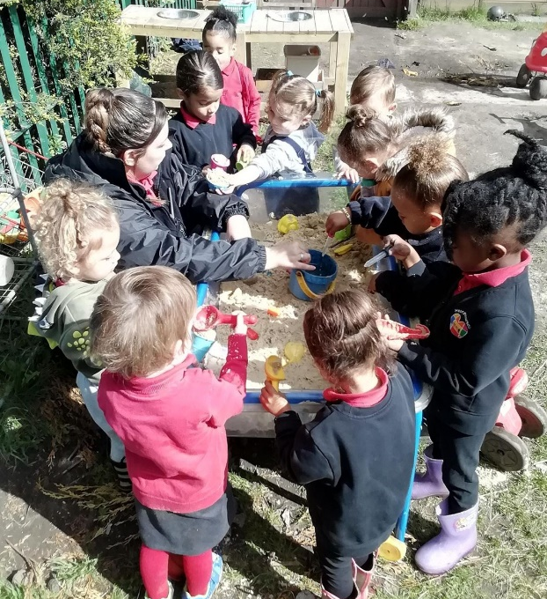
- First day of Autumn term: Thursday 2nd September

