Heart Preschool Newsletter
Christmas Activities Week
On the last week of term (13th-17th December) we will be having our Christmas Activity week, full of a variety of activities and events for our children and families to enjoy.
Christmas Craft Day – Monday 13th December
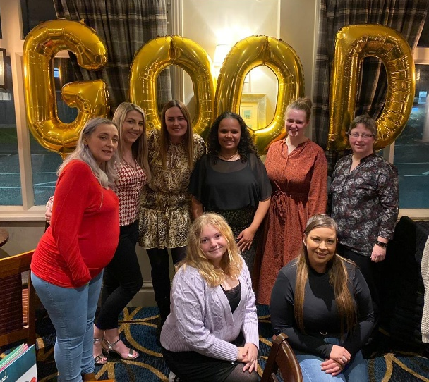
Wednesday 15th December: Christmas Performance, 1pm – we’ve started practising some Christmas songs to sing to you all! Each child can have up to two grown-ups attend the performance and then there will be the option to stay for mince pies and drinks after the performance has finished.
Thursday 16th December: Christmas Party Day – children can come in in their Christmas party clothes and we’ll have music, party games and party food with them.
Friday 17th December: Our cosy pyjama Christmas movie day – children can come in their snuggliest pair of pyjamas for a Christmas film and hot chocolate.
Friday 10th December is also Christmas Jumper Day to raise money for Save the Children! Children are encouraged to come in wearing their most festive jumpers, and donations of £1 towards Save the Children are very welcomed.
Ofsted ‘Good’ result!
As most of you now know we are officially rated ‘Good’ by Ofsted! We want to thank you all once again for your support and kind words on the day. The report is now available online at https://files.ofsted.gov.uk/v1/file/50171057 and our staff team have celebrated the achievement with a meal together. Well done Team Heart; staff, children and families alike!
Children in Need
A big thank you to all of you for your support during our Children in Need Day activities. Your donations meant that we raised £49.68 for this wonderful charity.
Volunteers
Our volunteers Ian & Kathryn have led some wonderful activities so far that have been really enjoyed by the children.
We’ve also welcomed a new student volunteer called Molly, who joins us on Wednesdays. She is with us as part of her work experience as she studies Health & Social Care at Oakwood Academy. Please thank them all for their support and hard work if you see them.

School Admissions
If your child turns 5 between 1 September 2022 and 31 August 2023, it is time to apply for their school place! The deadline for applications is 15th January, after this you may be less likely to get a place at your preferred school. To apply go to www.nottinghamcity.gov.uk/schooladmissions
For more information please see the blue poster outside our main door entrance.
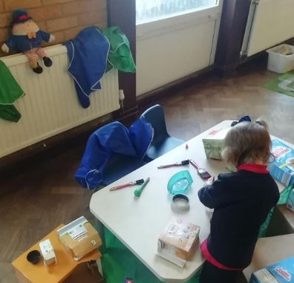

Nursery Rhyme Week
What a lot of fun we had for Nursery Rhyme Week! We did so many fun activities and sang so many songs, your children are superstar singers! Some highlights include; our Butterfly children going on a bus trip to the park (Wheels on the Bus), a farmyard sensory tuff spot outside (Old Macdonald), stargazing with torches in our blackout tent (Twinkle Twinkle) and building a box modelling wall for Humpty Dumpty.
If you missed our Nursery Rhyme videos on Famly you can find them on our website www.heartpreschool.co.uk

Dates for the diary
- Christmas activity week: 13th – 17th December (see details above)
- 17th December: Last day of term.
- 4th January: INSET Day (Staff training)
- 5th January: First day of term

- February half term: 14th – 18th February
- Easter holidays: 4th – 18th April (term starts Tuesday 19th April)
- June half term: 30th May – 3rd June
- Last day of summer term: Friday 22nd July
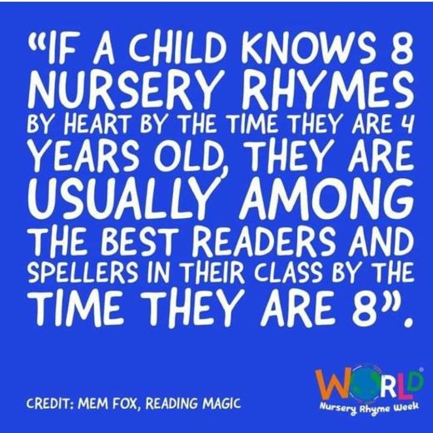
Community Events
Saturday 11th December, 1-3pm: Christmas Toy Swap at Bestwood Park Church, NG5 5NG. Bring your unwanted toys and swap for any on the table.
Sunday 19th December, 10am & 4pm: Family Carols and Nativity at Grace Church (NG7 1FT). Our own Rebekah will be leading a Nativity that is open to all families and children. Please see www.gracechurchnottingham.org/christmas for more details.

