Heart Preschool Newsletter
Introduction
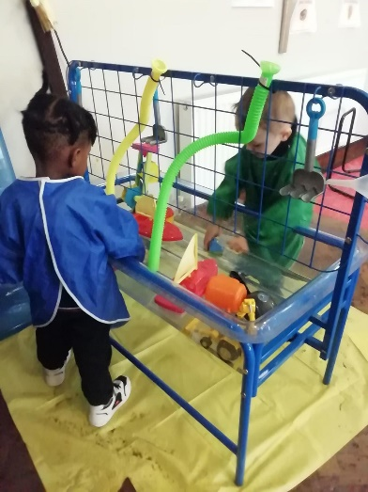
Hooray for another happy term of being able to stay open, with no coronavirus cases! Thank you to our families and staff for doing all they can to keep everyone safe during these challenging times. We will continue to do all we can to keep your little ones safe whilst they are with us. We’re enjoying the onset of spring and lots of lovely moments in the garden in the sunshine. Hopefully you are all feeling the sense of hope that comes with spring-time weather and longer days! You’re doing great!
It is wonderful that we are continuing to grow as a setting, and we want to say a very warm welcome to all our new children and families that have started since February half term, and we look forward to meeting new friends after the Easter holidays too. We also need to wish a sad goodbye to those children who are moving onto big school after Easter! We’ll miss you! We are so proud of every one of our children, old and new, and are so pleased with all the progress they’re making.
What’s been happening at Heart?
It’s been another term full of fun activities, lots of learning, and happy children! We were busy over February half term giving our Bubble 2 room a makeover, and the children have loved their new space. We’ve seen so much wonderful, focussed, independent play as our Bubble 2 children now have more activities and toys accessible to them throughout the whole week. Particular child favourites are our new quiet area, for some chilled out reading, constructing and sensory play, and our sand and water table and toys.
In Bubble 1 we’ve had lots of fun activities planned, from baking, to volcano science experiments, to maths challenges and making our own play dough! We’re so proud of how our Bubble 1 children are soaking up new skills and coming up with their own ideas every week.
Our outdoor area has seen a flurry of wildlife activity that has been so exciting for the children. We’ve seen lots of birds, and made bird feeders for them, we’ve enjoyed digging for wiggly worms and sometimes even being brave enough to hold them…we even had a cat visit us for a couple of days in our garden tree! And as always, we’ve done lots of active play with bikes, balls, climbing, and lots of jumping in muddy puddles! Please make sure your child has wellies to get muddy, and a pair of clean shoes and dry socks for inside each day.
ICAN Project
We are coming to the end of our ICAN Project and we’re so proud of the progress our ICAN children have made. We’ve seen all of them take big leaps in their listening, understanding and speaking skills. Well done to them, and well done to all you parents that spent time reading the Jake & Tizzy books and having conversations with your children at home. We’d really appreciate any feedback you have and would love to hear any stories of WOW moments you’ve had at home.
Home Learning/Show & Tell
A quick reminder that you can post any activities or WOW moments your child has done at home on the ‘Journey’ section of the Famly app. We love hearing about them and celebrating them with you!
Dates for the diary
- Bank holiday: Friday 2nd and 5th April 2021
- Easter Holidays: Tuesday 6th April 2021 – 16th April 2021
- Bank Holiday: Monday 3rd May
- June half term: 31st May – 4th June
- INSET Day: Friday 16th July

Fee increase
A reminder that as of the 1st April 2021 our prices will be going up to £35 per 5 hour session or £25 for a 3 hour session.
This includes snacks and drinks plus quality teaching and learning.
This increase comes in line with the governments increase in the National Living Wage.

World Book Day
What a fun day we had reading lots of our favourite stories, and exploring activities based on the stories. Well done on such amazing costumes!
Comic Relief Carnival
Thank you for all your kind donations to Comic Relief this year. As a setting we raised £51.10 to support this deserving charity. And didn’t we have fun doing it! Dancing, fancy dress, exotic foods and our own carnival float! The children loved it!
“Can we have a carnival again?” Freddie – aged 30 months

